**Findings Report**

# Findings

## Demographics

**Sex**

From the doughnut chart below, it was evident to the researcher that 75% of the participants were male while 25% accounted for female participants.

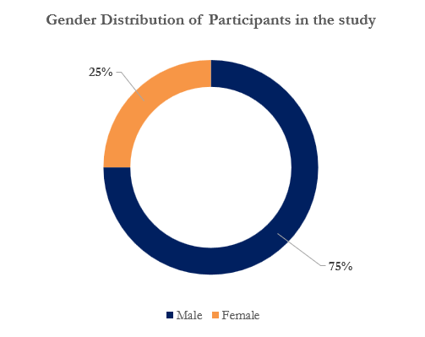

Figure 1: Doughnut chart showing the gender distribution of the participants in the study

**Age**

The majority of the participants were aged between 35-39 and 45-49 and they both accounted for 40% of the total participants respectively. 20% of the participants were aged between 30-34 years as shown in the pie chart below.

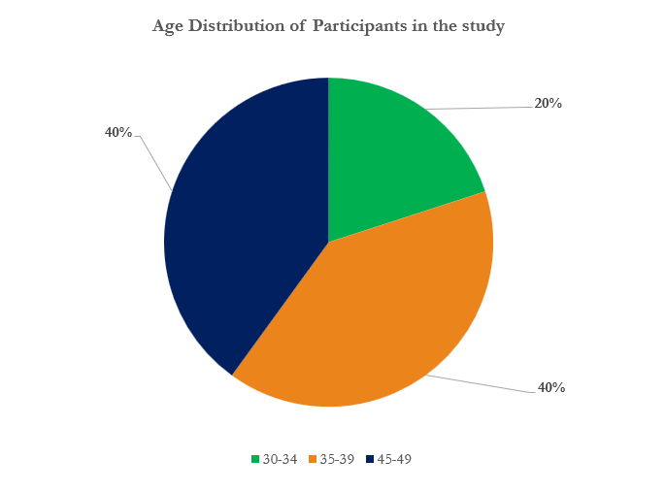

Figure 2: A pie chart showing the age distribution of the participants in the study

**Occupation**

From the bar plot below, it was evident to the researcher that 2 of the participants worked in the communities. The rest of the participants, one each, worked as DG-M-Justice, deputy district commission, and ministry staff respectively.

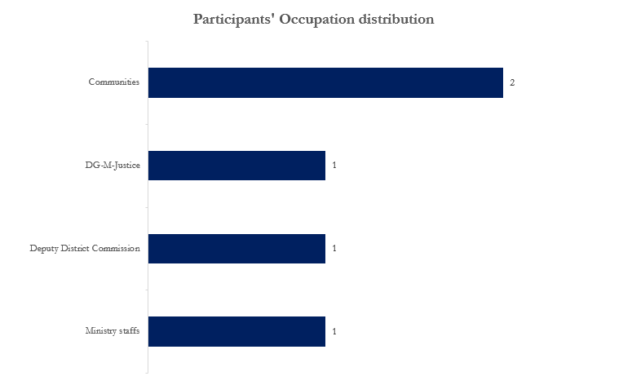

Figure 3: A bar plot showing the distribution of the participants' occupation

**Justice without discrimination**

60% of the participants strongly agreed that they had access to justice in their community without being discriminated against. Also, 40% of the participants agreed that they had access to justice in their community without discrimination as shown in the doughnut chart below.

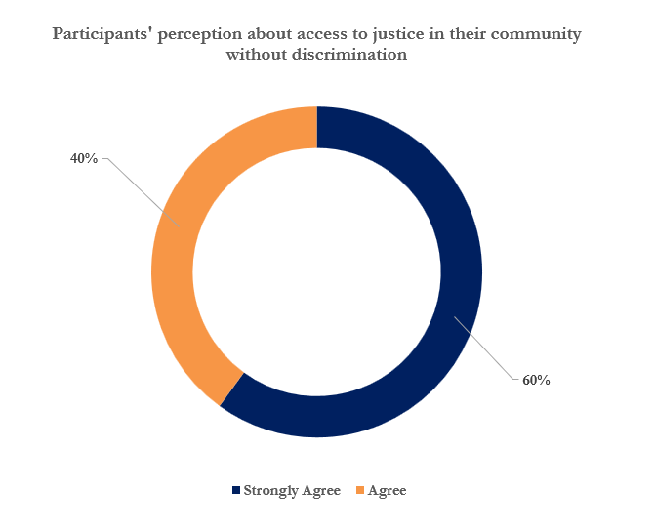

Figure 4: A doughnut chart showing participants’ perception of their access to justice in the community without discrimination

**Confidence in local administration**

From the doughnut chart below, it was evident that the majority of the participants sternly trusted their local administration and they accounted for 80%. 20% of the participants had a moderate level of trust in their local administration.

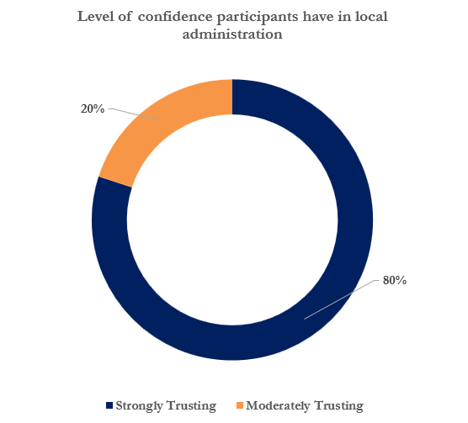

**Local administration addressing community needs**

80% of the participants believed that their local authorities completely addressed their community needs while 20% of the participants believed that their local authorities to a great extent addressed their community needs as shown in the doughnut chart below.

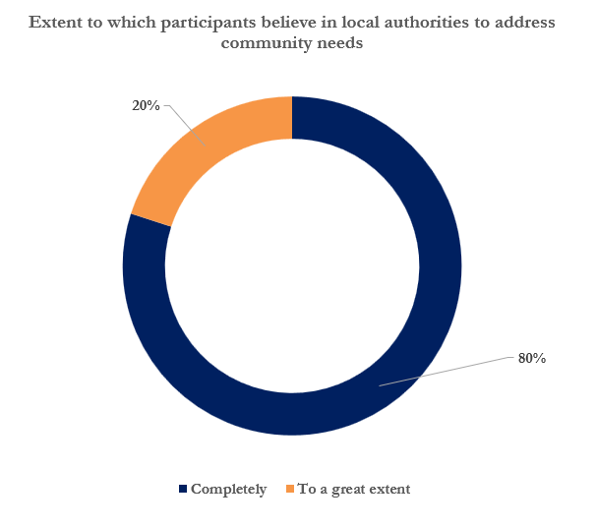

# Results

After conducting reflexive thematic analysis, the researcher was able to come up with the following main themes:

* Current situation and observed reports of conflicts in the area
* Significance and anticipated changes due to the construction of SWS office buildings
* Assessment of support through office buildings and additional thoughts regarding the topic

## Theme 1: Current security situation and observed reports of conflicts in the area

This theme examined the interviewees' perceptions of the security state in their area and delved into their responses regarding observed or reported conflicts and insecurities. 5 respondents, provided 18 statements leading to the development of this theme as shown in the table below.

|  |  |  |
| --- | --- | --- |
| **Theme | Subtheme** | **No. of Respondents** | **Coding References** |
| **Theme 1: Current security situation and observed reports of conflicts in the area** | **5** | **18** |
| **Subtheme 1.1:** Current security situation in the area | 5 | 9 |
| **Subtheme 1.2:** Observed or heard reports of conflicts or insecurity | 4 | 9 |

**Subtheme 1.1: Current security situation in the area**

This subtheme explored the interviewees' perceived thoughts about the current security situation in their area. Most of the respondents highlighted the lack of internal security offices and security threats as the current security state of their area.

Figure 5: Combined bar and line plot showing the current security situation in the participants’ area

Two of the participants, participants 4 and 5, articulated the current security state in their community was security threats in the area.

*Participant 4*

*lack of an office for internal security judiciary*

*Participant 5*

*the lack of permanent infrastructure for the SWS Ministries has posed challenges in taking decisive actions.*

Two other participants, participants 2 and 5, highlighted that their community was under constant security threats.

*Participant 2*

*the general situation are good prevalent societal conflicts in the area,*

*Participant 5*

*Minor conflicts, such as land disputes, especially during harvesting seasons, and occasional activities of rival militias in surrounding rural areas, have been observed but handled fairly.*

Other current security situations in the Baidoa community as stated by the participants included:

**Collaborating with stakeholders to enhance security**

*Participant 3*

*we’ve been working diligently to maintain stability and security within the town and surrounding villages, collaborating with various stakeholders, including community leaders, security forces, and relevant organizations. Our efforts have focused on enhancing security measures, conducting patrols, and engaging in dialogue to mitigate tensions and prevent further escalation of violence.*

**High taxes**

*Participant 4*

*high taxes*

**Monitoring security situation in the area**

*Participant 3*

*As local authorities in Baidoa town, we've been closely monitoring the security situation in the area.*

**Relative stability**

*Participant 1*

*The community enjoys relative stability, contributing to a favourable environment for development and prosperity.*

**Sense of security and safety**

*Participant 1*

*This stability fosters a sense of safety and security among residents, allowing them to engage in daily activities without fear of violence or instability.*

**Subtheme 1.2: Observed or heard reports of conflicts or insecurity**

This subtheme delved into the different instances that the interviewees gave in response to the observed or heard reports of conflicts or insecurities in their area. The most prevalent observed insecurity was tension from land disputes during the harvest season and occasional activities from militia groups perpetrating violence in rural areas, leading to the loss of innocent lives.

Three of the participants, participants 2, 4, and 5, expressed that they had observed conflict or insecurity in their area in the form of land disputes particularly during the harvesting season.

*Participant 2*

*land disputes, which escalate during harvesting seasons.*

*instances of land disputes, particularly prevalent during harvesting seasons, which often escalate tensions.*

*Participant 4*

*land disputes, particularly prevalent during harvesting seasons, which often escalate tensions.*

*Participant 5*

*Minor conflicts, such as land disputes, especially during harvesting seasons*

Three other participants, participants 2, 4, and 5, mentioned that there were occasional activities from militia groups perpetrating violence in rural areas, leading to the loss of innocent lives.

*Participant 2*

*concerns about insecurity caused by rival militias, leading to innocent lives being lost in rural areas.*

*concerns regarding insecurity, notably attributed to rival militias perpetrating violence in rural areas, leading to the loss of innocent lives.*

*Participant 4*

*concerns regarding insecurity, notably attributed to rival militias perpetrating violence in rural areas, leading to the loss of innocent lives*

*Participant 5*

*occasional activities of rival militias in surrounding rural areas, have been observed but handled fairly.*

Participant 3 articulated that there were persistent insecurities in the area as they stated:

*we've made progress in containing the situation, challenges persist, and we remain vigilant in our efforts to safeguard the safety and well-being of residents in Baidoa town.*

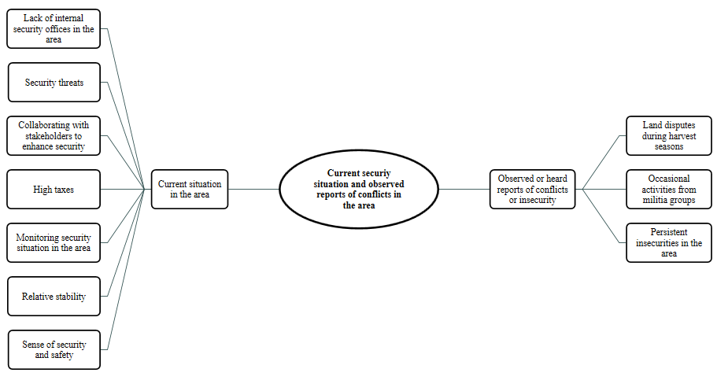

Figure 6: A mind map showing the current security situation and observed reports of conflicts in the area

## Theme 2: Significance and anticipated changes due to the construction of SWS office buildings

When asked about the significance of and the anticipated changes in the community as a result of the construction of SWS offices in the community, respondents had different responses hence leading to the development of this theme. 5 respondents provided 34 different statements that aided in the development of this theme as shown in the table below.

|  |  |  |
| --- | --- | --- |
| **Theme | Subtheme** | **No. of Respondents** | **Coding References** |
| **Theme 2: Significance and anticipated changes due to the construction of SWS office buildings** | **5** | **34** |
| **Subtheme 2.1:** Significance of constructing SWS Ministries of Justice and Internal Security office buildings | 5 | 22 |
| **Subtheme 2.2:** Changes anticipated within the community due to the construction of SWS office buildings | 4 | 12 |

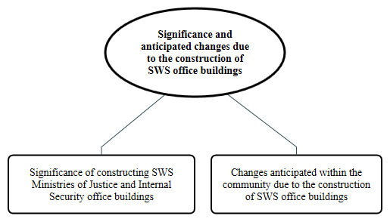

Figure 7: A mind map showing the significance and anticipated changes due to the construction of the SWS office building in the community

**Subtheme 2.1: Significance of constructing SWS Ministries of Justice and Internal Security office buildings**

Interviewees gave different responses in which the construction of office buildings for SWS Ministries of Justice and Internal Security was significant in their communities. The most prominent significances of constructing office buildings for SWS as articulated by the participants included resolution of security threats in the area and the offices being a central hub for government services.

Figure 8: Combined line and bar plot showing the significance of constructing SWS Ministries of Justice and Internal Security office buildings

Two of the participants, participants 2 and 3, mentioned that the construction of SWS offices in the community was important as they helped in resolving security threats in the area.

*Participant 2*

*establishment of a Justice office is perceived as essential for streamlining processes, enabling individuals to effectively address their grievances, and ultimately fostering a more just and equitable community environment.*

*Participant 3*

*These buildings serve as central hubs for crucial governmental functions, facilitating effective governance, law enforcement, and justice administration.*

*having dedicated office spaces provides a professional environment for ministry officials to carry out their duties efficiently. It enables them to coordinate operations, hold meetings, and manage resources effectively, ultimately enhancing the delivery of services to the public.*

Two other participants, participants 4 and 5, stated that the construction of SWS ministry offices was significant as they provided a central hub for government services.

*Participant 4*

*address the myriads of cases and issues that arise daily within the community.*

*Establishing this office is seen as pivotal in facilitating access to justice and resolving community concerns efficiently.*

*Participant 5*

*we welcome it this is because once we get the office cases of insecurity observed*

*conflict will become minimal since the office will address this kind of errors to get solved*

Other significant ways in which the construction of SWS ministry offices in the Baidoa community as stated by the participants included:

**Access to support when resolving issues**

*Participant 2*

*Without such infrastructure, individuals face significant hurdles in resolving their issues and accessing support from the Ministries of Southwest State.*

**Addressing security challenges through policy implementation**

*Participant 3*

*Moreover, having well-equipped office buildings enhances the capacity of the Ministries of Justice and Internal Security to address security challenges, investigate crimes, and administer justice. It allows for better coordination with law enforcement agencies and enables the implementation of policies and initiatives aimed at enhancing security and promoting peace in Baidoa and surrounding areas.*

**Boosting employee productivity and job satisfaction**

*Participant 1*

*providing comfortable work environments can boost employee productivity and job satisfaction, thereby enhancing the overall effectiveness of the Ministry of Justice.*

**Capacity building**

*Participant 3*

*The construction process itself can contribute to capacity building within the community. Local contractors, laborers, and businesses may be involved in the construction, providing employment opportunities and skills development. This can have long-term benefits for the local workforce and economy.*

**Capacity to deliver essential public services**

*Participant 1*

*Modern, well-equipped offices are vital for improving the government's capacity to deliver essential public services, particularly access to justice and security, essential for societal stability.*

**Community engagement**

*Participant 3*

*The construction project can serve as a catalyst for community engagement and participation. Public consultations, feedback mechanisms, and involvement in decision-making processes related to the design and implementation of the buildings can foster a sense of ownership and pride among residents.*

**Enhancing operational efficiency**

*Participant 1*

*This expansion will accommodate multiple departments, enhancing operational efficiency.*

**Improved community accountability through the establishment of ministry offices**

*Participant 4*

*improving accountability and justice within the community.*

**Quick action on insecurities and other criminal cases**

*Participant 5*

*This is because when the building is established cases of insecurity and others criminal will be raised hence no further delay of action.*

**Sense of stability**

*Participant 3*

*The presence of government buildings signifies stability and reinforces the community's confidence in the local government's ability to provide essential services and maintain order. This sense of stability can have a calming effect on residents and encourage investment and growth.*

**Streamlining the case resolution process**

*Participant 2*

*establishment of a Justice office is perceived as essential for streamlining processes,*

**Symbol of progress**

*Participant 3*

*The completion of the office buildings can serve as a symbol of progress and development for the community. It represents tangible evidence of government investment in infrastructure and services, showcasing forward momentum and a commitment to improving the lives of residents.*

**The construction of ministry buildings serves as a tangible symbol of government dedication in terms of justice**

*Participant 1*

*The construction of ministry offices serves as a tangible symbol of the government's dedication to strengthening the rule of law and the justice sector. This can have a positive psychological impact on both the public and government officials.*

**The construction of offices will provide a platform to air and address grievances**

*Participant 4*

*the upcoming establishment of such an office will provide a platform to address grievances more effectively in the future*

**This signifies government commitment and stability in fighting insecurities**

*Participant 3*

*these buildings signify the government's commitment to establishing a strong presence in Baidoa, which is essential for maintaining law and order, ensuring public safety, and upholding the rule of law. They serve as symbols of stability and authority, instilling confidence in the local population and signaling the government's investment in the region's development.*

**Subtheme 2.2: Changes anticipated within the community due to the construction of SWS office buildings**

This subtheme explored the different responses about what the interviewees anticipated to change in their community as a result of the construction of office buildings for SWS Ministries of Justice and Internal Security. The most prominent changes anticipated by the participants included a reduction in the number of unresolved cases and enhanced security in the community.

Participants 2 and 5 asserted that they anticipated to see a decrease in the number of unresolved cases in their community.

*Participant 2*

*decrease in worries about unresolved justice and security matters, contributing to a safer and more stable environment.*

*Participant 5*

*First the construction will help the needs of raising problems that was actually not been considered earlier before the establishment of the office.*

Other changes anticipated by the participants as a result of constructing offices for SWS in the Baidoa community included:

**Better equipped institutions**

*Participant 1*

*These institutions will be better equipped to serve the needs of the people, fostering stability and progress in the region.*

**Community empowerment**

*Participant 3*

*The construction of these buildings can empower the community by providing opportunities for engagement with government officials, participation in decision-making processes, and access to resources and support services. This fosters a sense of ownership and civic pride among residents.*

**Enhanced security**

*Participant 3*

*The presence of well-equipped facilities for the Ministry of Internal Security will lead to enhanced security measures in the region. This includes better coordination of security operations, intelligence gathering, and response to security threats, resulting in increased safety for residents and businesses.*

**Improved service delivery**

*Participant 3*

*With dedicated office spaces, the ministries can operate more efficiently, leading to improved service delivery to the community. Residents will have better access to legal services, law enforcement assistance, and government support, enhancing overall satisfaction with government services.*

**Improved ways of handling insecurities in the community**

*Participant 2*

*The female and male respondent emphasizes the positive impact of the office, particularly in handling reported cases of insecurity and reducing related issues within the community. With a dedicated space for addressing these concerns*

**Improvement in viability and sustainability of services**

*Participant 1*

*The construction of office buildings for the Ministries of Justice and Internal Security will lead to a noticeable improvement in the long-term viability and sustainability of community services and assets in the Southwest State.*

**Offices to offer storage of ministry's documents**

*Participant 5*

*Secondly it will be another advantage for the Ministries to have there documentation in there office exactly as they were not working in the area before*

**Promotion of investment and development**

*Participant 3*

*The establishment of government infrastructure demonstrates stability and government presence in the region, which can attract investment and spur economic development. This can lead to job creation, improved infrastructure, and overall growth in the local economy.*

**Resolution of recurrent cases**

*Participant 2*

*she believes that the establishment of the office will effectively address recurrent cases, leading to their resolution and subsequent decrease in frequency, ultimately promoting community safety and well-being.*

**Strengthened rule of law**

*Participant 3*

*The construction of office buildings for the Ministry of Justice signifies a commitment to upholding the rule of law. It provides a central location for legal proceedings, promotes transparency and accountability in the justice system, and ensures that residents have access to fair and impartial justice.*

## Theme 3: Assessment of support through office buildings and additional thoughts regarding the topic

This theme delved into the interviewees' perceptions regarding how the construction of SWS office buildings would address the needs of their community. Additionally, it examined additional thoughts and suggestions provided by the interviewed participants regarding the current situation and the impact of constructing ministry buildings in their community. 5 respondents gave 22 different statements that facilitated the development of this theme as shown in the table below.

|  |  |  |
| --- | --- | --- |
| **Theme | Subtheme** | **No. of Respondents** | **Coding References** |
| **Theme 3: Assessment of support through office buildings and additional thoughts regarding the topic** | **5** | **22** |
| **Subtheme 3.1:** Assessment of how support addresses community needs | 5 | 11 |
| **Subtheme 3.2:** Additional thoughts regarding the topic | 5 | 11 |

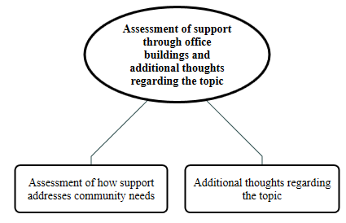

Figure 9: Mind map showing the respondents’ assessment of support they received through the construction of SWS office buildings and additional thoughts they had regarding the topic

**Subtheme 3.1: Assessment of how support addresses community needs**

This subtheme explored the interviewees' thoughts on how the construction of SWS office buildings would address the needs of their community. From the interviews, the most prevalent form of how support received from the construction of SWS office buildings addressed community needs as highlighted by the participants was access to justice and enhanced security.

Five of the participants, participants 1, 2, 3, 4, and 5, mentioned that support received as a result of the construction of SWS offices addressed community needs as it gave them access to justice.

*Participant 1*

*The establishment of office space for the Ministry will have a positive impact on the community by improving access to justice for all residents.*

*Participant 2*

*having a designated space where people can report incidents and share information will be beneficial for addressing security challenges effectively.*

*Participant 3*

*The construction of office buildings for the Ministry of Justice ensures better access to justice for community members. It provides a suitable environment for legal proceedings, facilitates the administration of courts and legal services, and ensures that justice is dispensed fairly and efficiently.*

*Participant 4*

*having a designated space where people can report incidents and share information will be beneficial for addressing security challenges effectively.*

*Participant 5*

*the community will now be able to use the site to raise their cases and it will*

Three other participants, participants 3, 4, and 5, articulated that the support they received from the construction of SWS offices enhanced security in the community.

*Participant 3*

*Having well-equipped facilities for the Ministry of Internal Security allows for better coordination of security operations, intelligence gathering, and law enforcement activities. This, in turn, contributes to improved public safety, reduces crime rates, and instils confidence in the community.*

*Participant 4*

*the importance of this initiative in improving community well-being and fostering a safer and more just environment.*

*Participant 5*

*useful for SWS Ministries to use as an alarm system to help them solve problems.*

Two other participants, participants 1 and 3, mentioned that the support they received from SWS offices was an improved governance system.

*Participant 1*

*This initiative recognizes the Ministry's significant influence on community affairs and underscores its commitment to serving the needs of the people.*

*Participant 3*

*The presence of dedicated office spaces for these ministries will enhance governance by providing a centralized location for administrative activities. This facilitates better coordination, decision-making, and implementation of policies, ultimately leading to more effective governance.*

Participant 3, highlighted that the support they received from SWS offices as a result of constructing their offices was increased investment and development in the community.

*Participant 3*

*The construction of government infrastructure signifies investment in the community and demonstrates a commitment to its development. It can attract further investment, stimulate economic growth, and create employment opportunities, thereby benefiting the overall well-being of the community.*

**Subtheme 3.2: Additional thoughts regarding the topic**

This subtheme examined additional thoughts and suggestions from the interviewed participants regarding the current situation and the impact of the construction of ministry buildings in their community. The most prevalent thoughts and suggestions by the interviewees were the need to encourage residents to remain vigilant and report suspicious activities, and that the district needed to establish more police facilities in the region e.g., police cells to accommodate law enforcement demands.

Two of the participants, participants 1 and 3, suggested that residents needed to be encouraged to be vigilant and report any suspicious activities in the area.

*Participant 1*

*it's essential to remain vigilant and continue efforts to maintain peace and security, ensuring that the positive conditions in the area are sustained for the well-being of all community members.*

*Participant 3*

*We encourage residents to remain vigilant and report any suspicious activities to the authorities to help maintain the safety and security of our communities.*

Two other participants, participants 2 and 4, recommended that there was a need to establish more police facilities such as police cells in the area to accommodate the community’s law enforcement demand efforts.

*Participant 2*

*the importance of addressing insecurity and minor conflicts through the establishment of police cells, particularly due to the limited number available in the district.*

*there is a pressing need for additional cells to accommodate the demands of the community and ensure that law enforcement efforts can be carried out efficiently and effectively.*

*Participant 4*

*the importance of addressing insecurity and minor conflicts through the establishment of police cells, particularly due to the limited number available in the district.*

*there is a pressing need for additional cells to accommodate the demands of the community and ensure that law enforcement efforts can be carried out efficiently and effectively.*

Other suggestions and thoughts from the interviewed participants about the topic included:

**Encouraging community support and cooperation**

*Participant 3*

*We continue to encourage cooperation and support from all members of the community to promote peace and stability in the region.*

**Future expectations to enhance justice and reduce security threats**

*Participant 5*

*The establishment of dedicated offices for the Ministries of Justice and Internal Security is anticipated to further improve access to justice and enhance security measures, ensuring more effective resolution of conflicts and sustained stability in Baidoa and its environs.*

**Lack of offices hinders the resolution of daily problems and cases**

*Participant 2*

*This lack of accessibility poses a substantial challenge, hindering the effective resolution of daily problems and cases that arise.*

**Proactive conflict resolution measures**

*Participant 3*

*The presence of government buildings signifies stability and reinforces the community's confidence in the local government's ability to provide essential services and maintain order. This sense of stability can have a calming effect on residents and encourage investment and growth.*

**Wide range of justice in the region through the construction of offices**

*Participant 5*

*The construction of office for the Ministries especially Ministries of Justice and Internal Security will bring a wide range of Justice towards the community as well as the entire region this is because once you have the location you have the access to handle cases from diffraction of community and this will bring a great impact for us.*

# Key

## Theme and theme descriptions

|  |  |
| --- | --- |
| Theme | Subtheme | Description |
| **Theme 1:** Current situation and observed reports of conflicts in the area | This theme examines interviewees' perceptions of security in their area and delves into their responses regarding observed or reported conflicts and insecurities. |
| **Theme 2:** Significance and anticipated changes due to the construction of SWS office buildings | This theme focuses on the interviewees' perspectives on the significance of constructing office buildings for SWS Ministries of Justice and Internal Security in their communities. It further examines their anticipations regarding the potential changes in their communities resulting from this construction. |
| **Theme 3:** Assessment of support through office buildings and additional thoughts regarding the topic | This theme delves into interviewees' perceptions regarding how the construction of SWS office buildings will address the needs of their community. Additionally, it examines any additional thoughts and suggestions provided by interview participants regarding the current situation and the impact of constructing ministry buildings in their community. |

## Participants

|  |  |
| --- | --- |
| Participant | Pseudo name |
| DG Justice Interview | Participant 1 |
| Female Respondent | Participant 2 |
| LA interview | Participant 3 |
| Male Respondent | Participant 4 |
| Ministry of Security Staff 1 | Participant 5 |